TO: MSCA Members

FROM: MCA-Omaha

RE: Reporting MSCA Hours (Reminder of Process)

Your MSCA hours are service hours and MCAA hours are construction hours.

Please use the attached form to report your 2018 MSCA hours (service hours) to MCA-Omaha at michele.mcaomaha@gmail.com or fax to 402.592.3975 each month when you submit your hours to the Benefits Office and/or BeneSys. You have been given one sheet with your company name and MCAA/MSCA ID Number on it.

Fill in the date, pay period starting and ending dates, and the number of service hours worked. Multiply the service hours by $.08 for your total dues that will be sent to MSCA.
(Do NOT send a check, it will be taken out of what you already send.)

This form is just a way for us to break out your national dues to MCAA and MSCA in a fair and accountable manor.

Please give us a call if you have any questions.

Michele Hoffman
MCA-Omaha Associate Executive
michele.mcaomaha@gmail.com
402.592.333
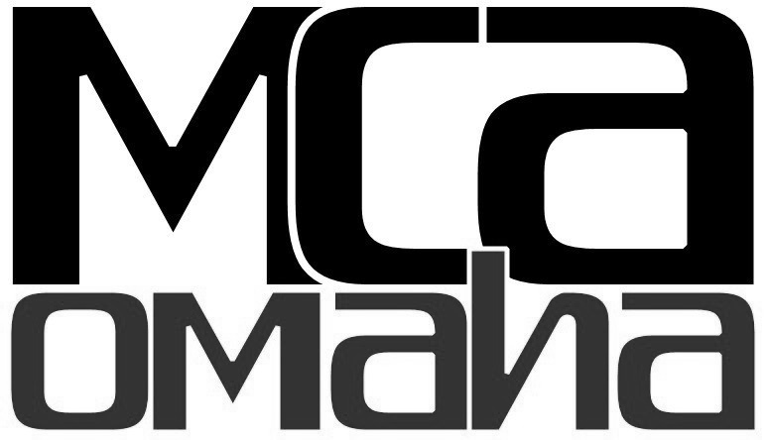

2018 MSCA Monthly Hours Report

Company Name: ______________________________________________

MCAA/ MSCA ID #: ____________________________________________

Current Date:__________/__________ 2018

Pay Period Pay Period
Starting Date:________________________ to Ending Date:____________________

MSCA Service Hours Worked (#)_________________________
(Still include these hours in your total hours report to the Benefits Office/ BeneSys, but this is for MCA-Omaha to separate out a % of your national dues to MSCA.)

X $.08 Dues Payable Per Hour

Total: $____________________________

Please submit this form to MCA-Omaha at michele.mcaomaha@gmail.com or fax to 402.592.3975 when you normally submit your hours report to the Benefits Office and/or BeneSys each month.

Michele Hoffman – Associate Executive
Phone: 402.592.3330 Fax: 402.592.3975 Email: michele.mcaomaha@gmail.com

